**Pong Design Document**

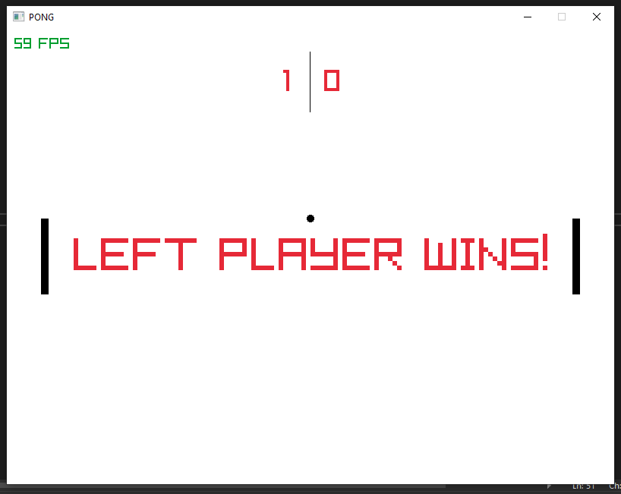Objects to create

* Paddle for left and right side
* Ball
* Scoreboard
* 800 x 600 screen
* FPS count
* Winner text

Details of Game

The game is a standard pong game. It is a 2-player game, one player controls the left paddle and the other controls the right paddle. Both paddles can only move up and down and are bound to the dimensions of the screen. The ball starts in the middle of the screen and begins moving towards one of the players paddles. The aim of the game is to stop the ball from going behind your paddle, to do this you move the paddle into the path of the ball, and it bounces off and heads back towards the opposing player. If the ball goes past your paddle, then the opposing player wins that point and you press space to restart again. The score tally’s up until the game is closed.

I will create structs for the ball and paddles, which contain the positions, speed, size and a draw function. The values for the structs are initialised in the main function along with the window and score values.

To start with I will give the ball speed along the x and y axis to make it move then add if statements to bounce the ball off the top and bottom of the screen. Then I give the paddles vertical movement controlled by the user and bound it to the top and bottom of the screen.

The collision checking when the ball hits a paddle is the most technically difficult part of the code to understand and implement. The ball speeds up slightly after each paddle collision to add progressive difficulty to the game otherwise it could be played forever which would not be fun. While checking the collision I also adjust the bounce angles of the ball to add more unpredictability to the game. The closer to the edges that the ball collides the larger the angle it bounces off at.

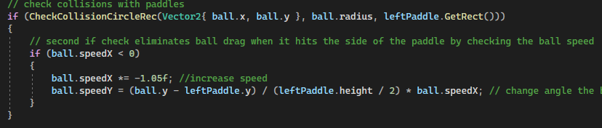

I create the logic for a winner screen and a score tally when the ball goes past either of the paddles, then implement restart functionality when the space bar is pressed so the players can play for as long as they want and keep score. Score resets when game is closed. Finally, it is all drawn in the draw function at the appropriate times.